Project Proposal – 24/7 Holds Lockers

Damion Beckett – Budget
Steven Gurney – Project Partners & Assessment
Kassady Lewis – Timeline
Selena Palacios – Problem Statement, Solution, & Required Resources
Elizabeth Zimmerman – Editor
University of South Florida
LIS 6409
Dr. Barbara Stites
30 June 2024

PROBLEM
The number of unclaimed holds at Sun County Public Library (SCPL) has increased drastically: up to 39% in the last two fiscal years, according to the yearly statistics shared internally. Patrons have stated that the current library hours do not work with their ability to pick up holds or use other library services. These unclaimed holds have also increased wait times for popular books as well as the load of transit items for the library couriers.

SOLUTION
SCPL’s customer service committee is proposing the implementation of four 24/7 holds lockers at four library locations in Sun County as an initial trial run. These lockers will be placed outside of the libraries so that they may be accessible to patrons after hours. When patrons initially place holds on materials through the OPAC, they will be able to choose to pick up their holds at one of the lockers. The ILS will then reserve an available locker and notify patrons through text with an access code when their hold is ready for pick up. When the patron uses the access code at the holds lockers and the locker is opened, the ILS will then automatically check out the materials on the patron’s account.

REQUIRED RESOURCES
Staffing: IT personnel and a support services manager that will work with Intelligent Library Locker to create locker code and integrate library user information; circulation branch manager will monitor the implementation of the lockers and their progress.

Equipment: Four 24/7 holds lockers from Intelligent Library Locker Systems

Training: Support staff at the four branches will undergo training on how to stock, retrieve, and do basic troubleshooting of locker equipment as well as how to answer patron questions regarding this new service.

PROJECT PARTNERS
Manager of the Library Support Services division
Library Systems & Technology (LST)
Intelligent Library Locker Systems
Library circulation manager for each library (as branch project contact)
Expedite Delivery Service
Circulation staff in each library

The Library Support Services division manager will be the point person and project coordinator responsible for ensuring planning, installation, assessment, and enhancement and is the main report to the library director. The library technology manager and their technology department will be tasked with partnering with Intelligent Library Locker Systems in developing a drop-down menu option in the catalog of the OPAC. They will provide the technical support for the ordering and notification system to autogenerate temporary locker passwords and send text notifications that hold(s) will be ready for pickup. The library circulation manager for each Locker Library will closely monitor the progress of project implementation for their branch. They will report on any technical issues, customer comments, and customer suggestions to the Library Support Services manager and will work closely with branch circulation staff to ensure a smooth transition. The Expedite Delivery Service will be trained in delivering the holds and stocking the lockers in remote locations if they are deemed necessary for smaller branches. Circulation staff will also be trained in locker operation for hold lockers on-site at library locations.

Proposed Organization Chart
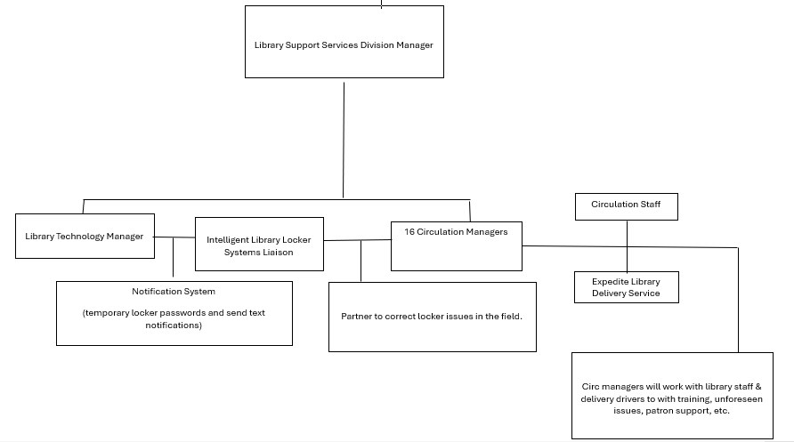ASSESSMENT
For many years, hold pickup rates have been steadily declining in our library system. After extensive study of the issue, we have determined that the source of the problem is that our hours of operation do not coincide with the busy lives of patrons as well as we would like. Accessibility is one of the main tenets of librarianship and intellectual freedom. It is the mission of every ALA-member library to unite people with the information they seek. In recent years, libraries have made great strides in the cause of patron accessibility with 24-hour access to digital media by employing services like Hoopla and Libby. Today, SCPL is ready to take the next step in expanding patron accessibility.
Between May 1st and July 31st of 2023, SCPL conducted research into potential enhancements to be made to library services. In all 16 branches, library administration crafted surveys about potential service upgrade options and emailed them to all patrons. In addition to the surveys, SCPL hired the L&E Research Group, a reputable marketing firm, to conduct further research using focus groups. In both the surveys and the focus groups, the 24/7 holds locker program was the most requested library service upgrade.

Based on our study with L&E Research, we estimate that providing patrons with 24/7 access to holds for pickup will decrease our unclaimed hold rate by at least 25% in the first year of use while increasing patron satisfaction with library services by 15%. SCPL’s goal is to reduce expired holds even further as the holds locker program extends to every library in the system. Conservatively, we estimate unclaimed holds will be reduced by at least 35% in the second year. Once patrons have acclimated to the concept of hold lockers, we estimate patron service satisfaction will increase by at least 20%. Based on the focus group studies done on 24/7 holds lockers, patrons find them easy to understand and use. In addition, patrons also approve of the convenience of time and location.

Our funding approval target date is the 1st of October 2024. We plan to start the program about a week after that by informing the staff and printing promotional materials. After that, on or around the 14th of October, we will negotiate a contract with Intelligent Library Locker Systems and inform our IT department that we need them to work with Intelligent Library Locker Systems on developing a locker code system that can be linked to patron accounts. On the 28th admin plans to finalize the deal with Intelligent Library Locker Systems. In early November, the plan is to begin promoting the program, announce the go-live date for the hold lockers, and begin locker installation on all library campuses on the 4th. On December 2nd, IT will complete locker code generation to patron account integration and physically test its functionality. December 9th is our go live date for the hold lockers. IT and Intelligent Library Locker Systems will be on hand for any technical issues that may arise. A few weeks later, the Manager of the Library Support Services will develop a survey for library users to rate and give input on the hold locker program on December 30th. After survey approval by the library board on January 6th, 2025, it will be sent out a few days later, on the 10th. We will continue to collect surveys until March 28th and begin data analysis on the 31st. Based on our analysis, a report on the hold locker program will be completed on April 28th. On May 5th, 2025, the report will be presented to the library board and then made public.
BUDGET
Salaries | Expenses | Comments
IT personnel (.04 FTE) | $ 2,400 | $30 / hour (80 project hrs.)
Reference Librarian (.03 FTE) | $ 1,500 | $25 / hour (60 project hrs.)
Stocker (Student worker) (.08 FTE) | $ 960 | $12 / hour (80 project hrs.)
Benefits
IT personnel (.04 FTE) | 184 | 7.65% FICA
Reference Librarian (.03 FTE) | 114 | 7.65% FICA
Stocker (Student worker) (.08 FTE) | 73 | 7.65% FICA
Contractual Services
Delivery | $ 10,000
Library Materials
None
Supplies
None
Travel
None
Equipment
None
Total | $ 15,231

TIMELINE
Due Date | Activity
October 1st, 2024 | Obtain approval for 24/7 hold locker implementation
October 7th, 2024 | Announce project to library staff
October 7th, 2024 | Develop promotional materials about the hold lockers
October 11th, 2024 | Obtain approval of promotional materials
October 14th, 2024 | Reach out to Intelligent Library Locker Systems to purchase/contract lockers
October 14th, 2024 | Reach out to IT about connecting hold locker codes to patron information (patron email/phone number)
October 28th, 2024 | Finalize deal with Intelligent Library Locker Systems and purchase hold locker
November 4th, 2024 | Begin promotion of 24/7 hold lockers
November 4th, 2024 | Delivery & installation of holds locker
November 4th, 2024 | Announce official opening date of holds lockers
December 2nd, 2024 | IT to complete locker code and user information integration
December 2nd, 2024 | IT to test functionality of hold locker code integration
December 9th, 2024 | Open hold lockers for patron use
December 30th, 2024 | Develop survey for library users on hold accessibility after locker implementation
January 6th, 2025 | Get survey approval
January 10th, 2025 | Send out surveys
March 28th, 2025 | Close surveys
March 28th, 2025 | Gather hold circulation data from library
March 31st, 2025 | Analyze survey and circulation data
April 28th, 2025 | Create a report using survey and circulation data
May 5th, 2025 | Share report on how hold lockers have affected hold pick-ups within the community

