Note: XML code is located after the screen shots.

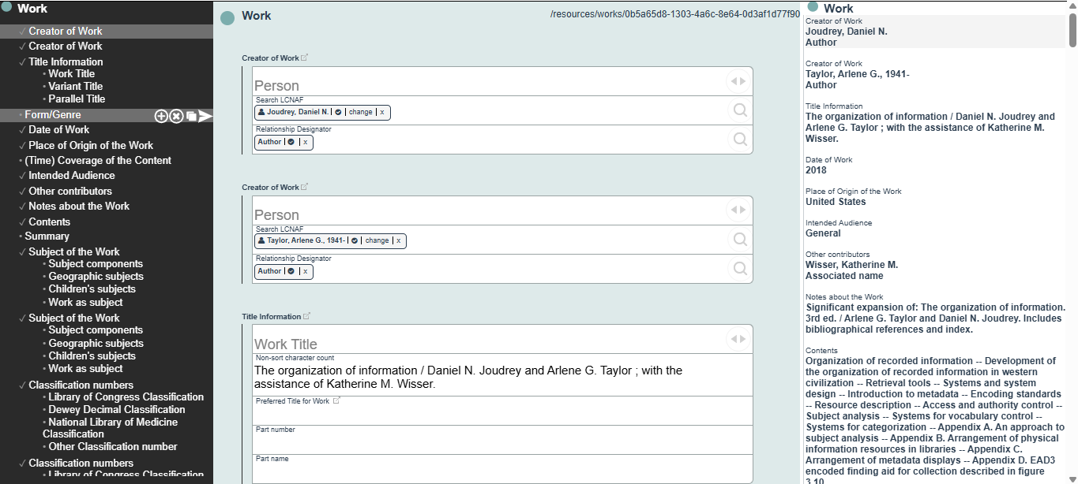
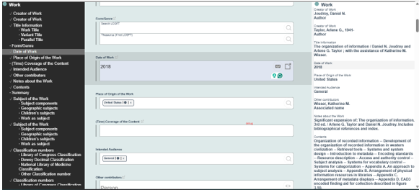
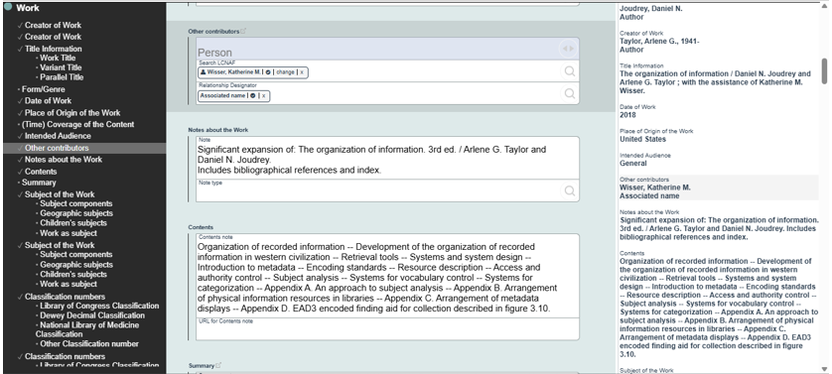
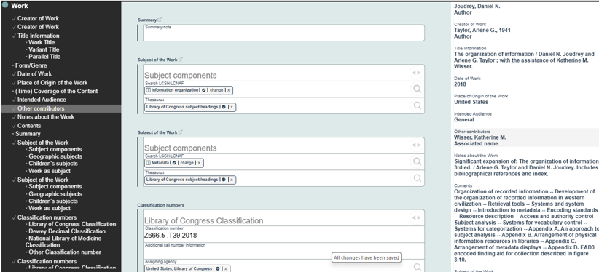
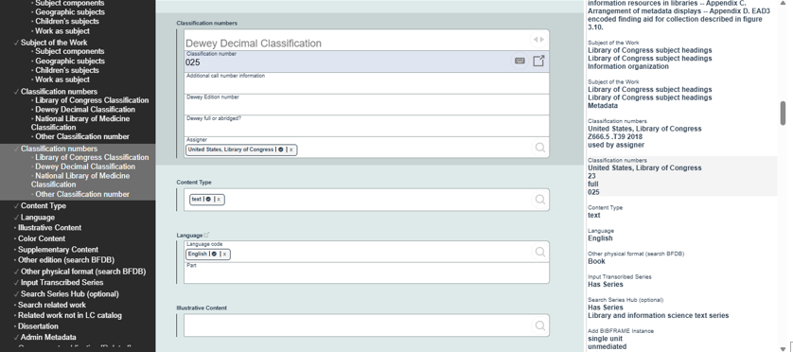
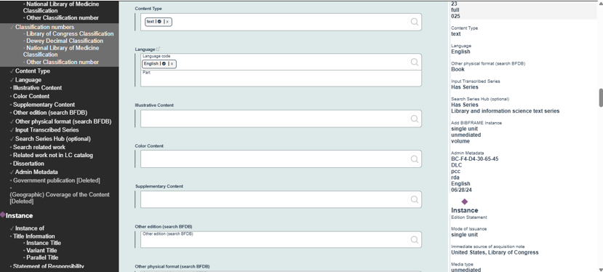
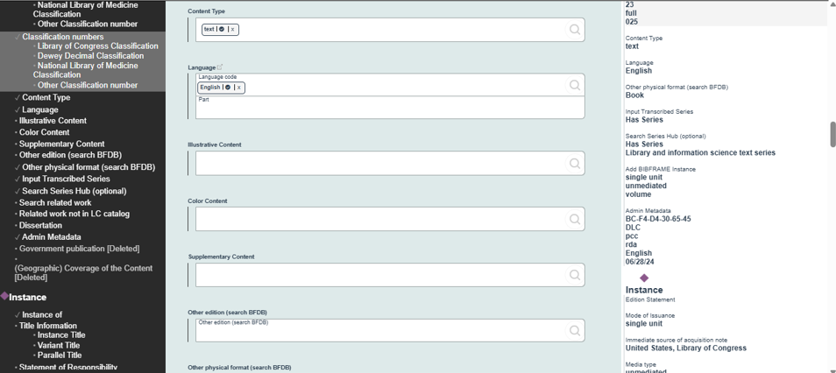
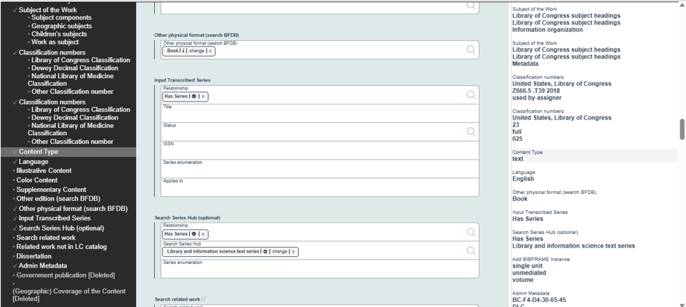
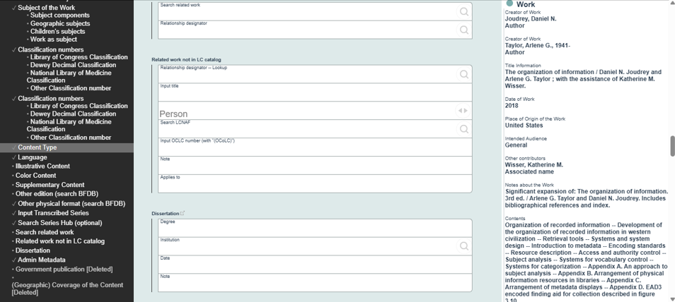
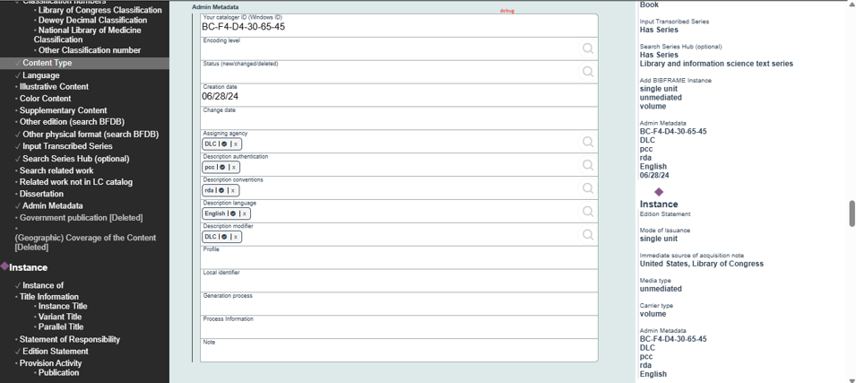
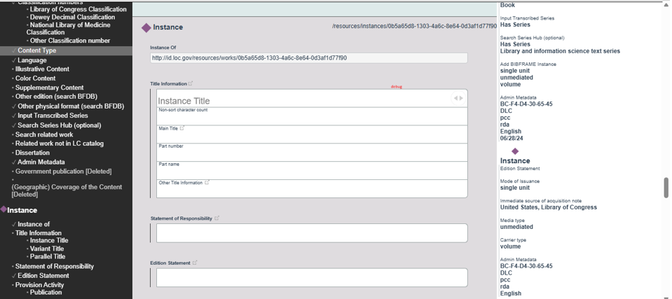
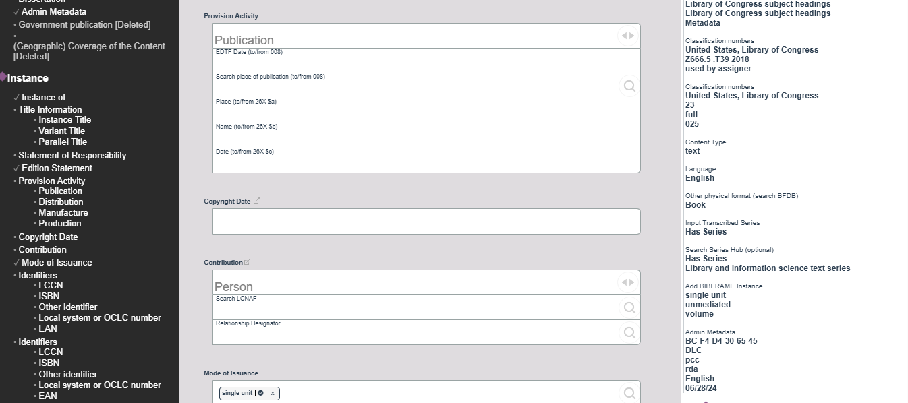
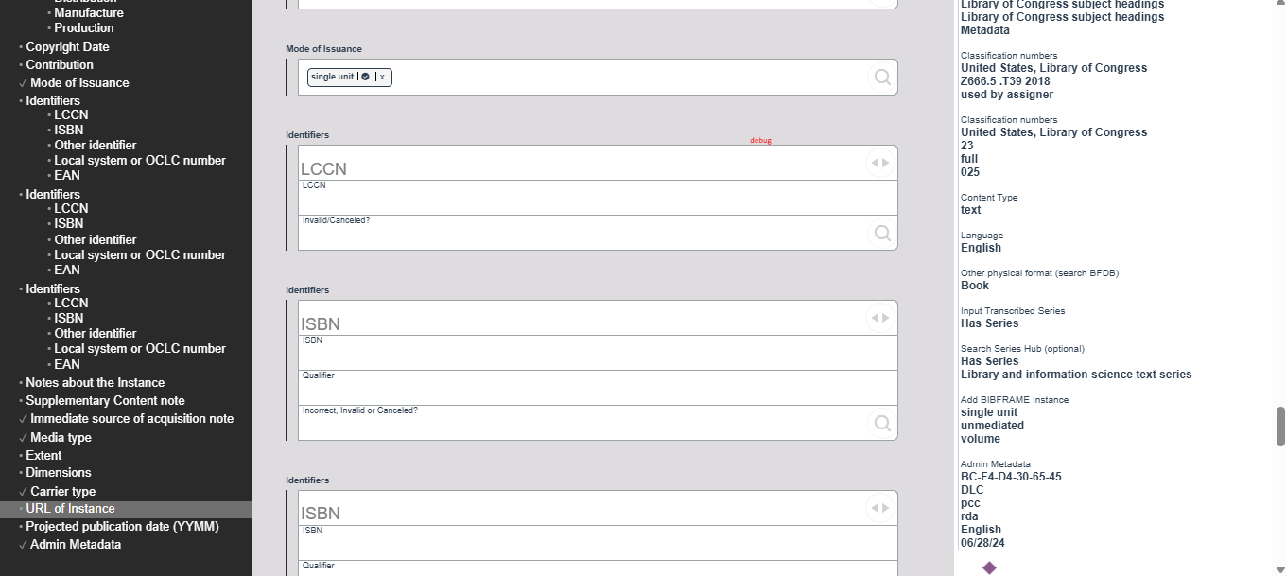
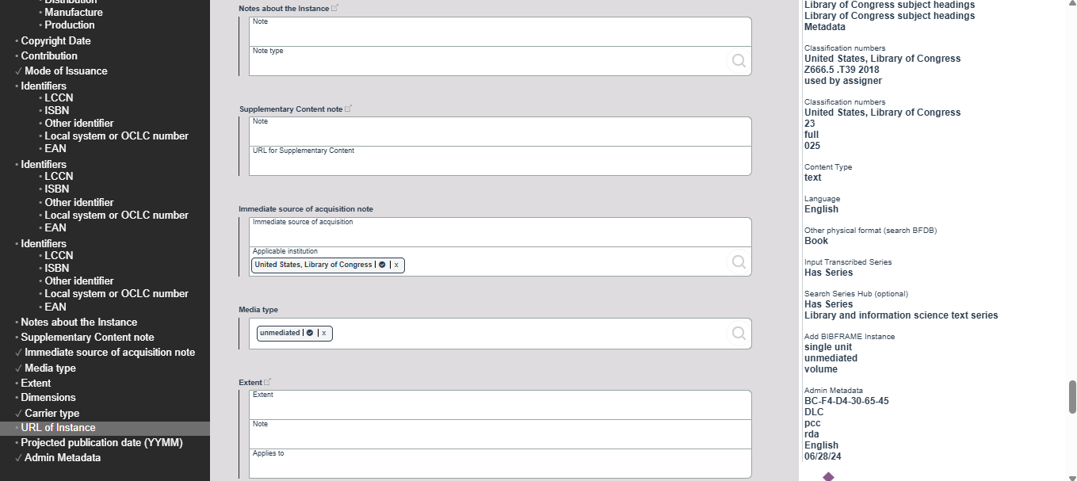
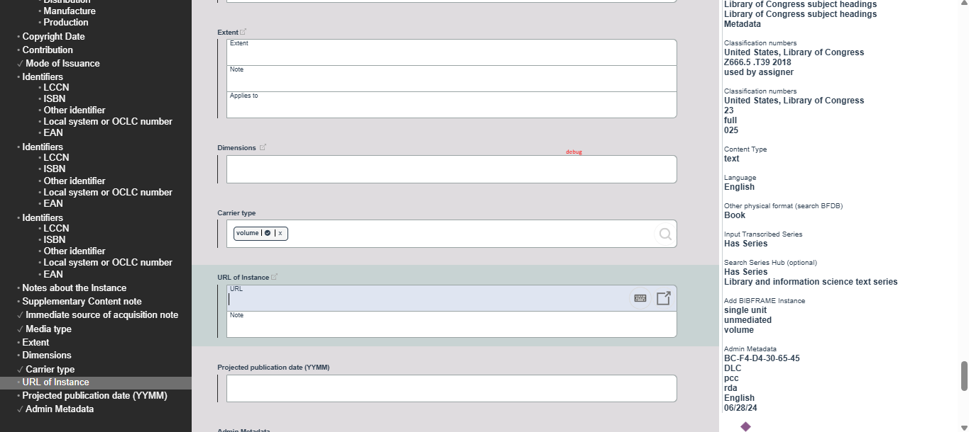
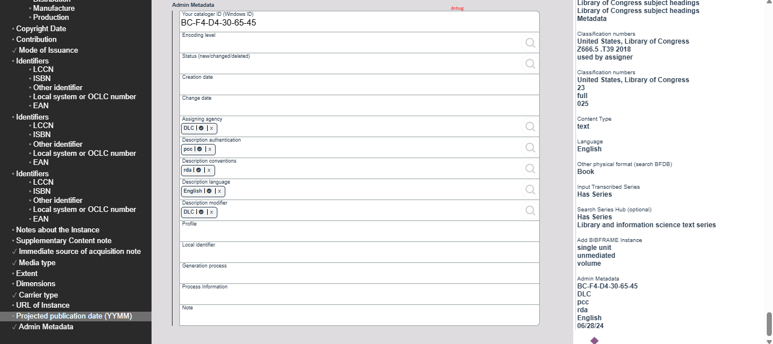

XML
<rdf:RDF xmlns:bflc="http://id.loc.gov/ontologies/bflc/" xmlns:bf="http://id.loc.gov/ontologies/bibframe/" xmlns:bfsimple="http://id.loc.gov/ontologies/bfsimple/" xmlns:madsrdf="http://www.loc.gov/mads/rdf/v1#" xmlns:rdfs="http://www.w3.org/2000/01/rdf-schema#" xmlns:rdf="http://www.w3.org/1999/02/22-rdf-syntax-ns#" xmlns:lclocal="http://id.loc.gov/ontologies/lclocal/" xmlns:pmo="http://performedmusicontology.org/ontology/" xmlns:datatypes="http://id.loc.gov/datatypes/" xmlns:xsd="http://www.w3.org/2001/XMLSchema#" xmlns:void="http://rdfs.org/ns/void#" xmlns:mstatus="https://id.loc.gov/vocabulary/mstatus/" xmlns:mnotetype="http://id.loc.gov/vocabulary/mnotetype/" xmlns:owl="http://www.w3.org/2002/07/owl#" xmlns:dcterms="http://purl.org/dc/terms/">
<bf:Instance xmlns:bf="http://id.loc.gov/ontologies/bibframe/" xmlns:rdf="http://www.w3.org/1999/02/22-rdf-syntax-ns#" rdf:about="http://id.loc.gov/resources/instances/0b5a65d8-1303-4a6c-8e64-0d3af1d77f90">
<bf:issuance>
<bf:Issuance rdf:about="http://id.loc.gov/vocabulary/issuance/mono">
<rdfs:label xmlns:rdfs="http://www.w3.org/2000/01/rdf-schema#">single unit</rdfs:label>
</bf:Issuance>
</bf:issuance>
<bf:immediateAcquisition>
<bf:ImmediateAcquisition>
<bflc:applicableInstitution xmlns:bflc="http://id.loc.gov/ontologies/bflc/">
<bf:Organization rdf:about="http://id.loc.gov/vocabulary/organizations/dlc">
<rdfs:label xmlns:rdfs="http://www.w3.org/2000/01/rdf-schema#">United States, Library of Congress</rdfs:label>
</bf:Organization>
</bflc:applicableInstitution>
</bf:ImmediateAcquisition>
</bf:immediateAcquisition>
<bf:media>
<bf:Media rdf:about="http://id.loc.gov/vocabulary/mediaTypes/n">
<rdfs:label xmlns:rdfs="http://www.w3.org/2000/01/rdf-schema#">unmediated</rdfs:label>
</bf:Media>
</bf:media>
<bf:carrier>
<bf:Carrier rdf:about="http://id.loc.gov/vocabulary/carriers/nc">
<rdfs:label xmlns:rdfs="http://www.w3.org/2000/01/rdf-schema#">volume</rdfs:label>
</bf:Carrier>
</bf:carrier>
<bf:adminMetadata>
<bf:AdminMetadata>
<bflc:catalogerId xmlns:bflc="http://id.loc.gov/ontologies/bflc/">BC-F4-D4-30-65-45</bflc:catalogerId>
<bf:assigner>
<bf:Agent rdf:about="http://id.loc.gov/vocabulary/organizations/dlc">
<rdfs:label xmlns:rdfs="http://www.w3.org/2000/01/rdf-schema#">DLC</rdfs:label>
</bf:Agent>
</bf:assigner>
<bf:descriptionAuthentication>
<bf:DescriptionAuthentication rdf:about="http://id.loc.gov/vocabulary/marcauthen/pcc">
<rdfs:label xmlns:rdfs="http://www.w3.org/2000/01/rdf-schema#">pcc</rdfs:label>
</bf:DescriptionAuthentication>
</bf:descriptionAuthentication>
<bf:descriptionConventions>
<bf:DescriptionConventions rdf:about="http://id.loc.gov/vocabulary/descriptionConventions/rda">
<rdfs:label xmlns:rdfs="http://www.w3.org/2000/01/rdf-schema#">rda</rdfs:label>
</bf:DescriptionConventions>
</bf:descriptionConventions>
<bf:descriptionLanguage>
<bf:Language rdf:about="http://id.loc.gov/vocabulary/languages/eng">
<rdfs:label xmlns:rdfs="http://www.w3.org/2000/01/rdf-schema#">English</rdfs:label>
</bf:Language>
</bf:descriptionLanguage>
<bf:descriptionModifier>
<bf:Agent rdf:about="http://id.loc.gov/vocabulary/organizations/dlc">
<rdfs:label xmlns:rdfs="http://www.w3.org/2000/01/rdf-schema#">DLC</rdfs:label>
</bf:Agent>
</bf:descriptionModifier>
<bflc:profile xmlns:bflc="http://id.loc.gov/ontologies/bflc/">lc:RT:bf2:Monograph:Instance</bflc:profile>
<bf:changeDate rdf:datatype="http://www.w3.org/2001/XMLSchema#dateTime">2024-06-29T02:43:48Z</bf:changeDate>
<bf:creationDate rdf:datatype="http://www.w3.org/2001/XMLSchema#dateTime">2024-06-29T02:43:48Z</bf:creationDate>
</bf:AdminMetadata>
</bf:adminMetadata>
<bf:instanceOf>
<bf:Work xmlns:bf="http://id.loc.gov/ontologies/bibframe/" xmlns:rdf="http://www.w3.org/1999/02/22-rdf-syntax-ns#" rdf:about="http://id.loc.gov/resources/works/0b5a65d8-1303-4a6c-8e64-0d3af1d77f90">
<bf:contribution>
<bflc:PrimaryContribution xmlns:bflc="http://id.loc.gov/ontologies/bflc/">
<bf:agent>
<bf:Agent rdf:about="http://id.loc.gov/authorities/names/no2006073134">
<rdf:type rdf:resource="http://www.loc.gov/mads/rdf/v1#PersonalName"/>
<rdfs:label xmlns:rdfs="http://www.w3.org/2000/01/rdf-schema#">Joudrey, Daniel N.</rdfs:label>
</bf:Agent>
</bf:agent>
<bf:role>
<bf:Role rdf:about="http://id.loc.gov/vocabulary/relators/aut">
<rdfs:label xmlns:rdfs="http://www.w3.org/2000/01/rdf-schema#">Author</rdfs:label>
</bf:Role>
</bf:role>
</bflc:PrimaryContribution>
</bf:contribution>
<bf:contribution>
<bflc:PrimaryContribution xmlns:bflc="http://id.loc.gov/ontologies/bflc/">
<bf:agent>
<bf:Agent rdf:about="http://id.loc.gov/authorities/names/n80050006">
<rdf:type rdf:resource="http://id.loc.gov/ontologies/bibframe/Person"/>
<rdfs:label xmlns:rdfs="http://www.w3.org/2000/01/rdf-schema#">Taylor, Arlene G., 1941-</rdfs:label>
</bf:Agent>
</bf:agent>
<bf:role>
<bf:Role rdf:about="http://id.loc.gov/vocabulary/relators/aut">
<rdfs:label xmlns:rdfs="http://www.w3.org/2000/01/rdf-schema#">Author</rdfs:label>
</bf:Role>
</bf:role>
</bflc:PrimaryContribution>
</bf:contribution>
<bf:title>
<bf:Title>
<bflc:nonSortNum xmlns:bflc="http://id.loc.gov/ontologies/bflc/">The organization of information / Daniel N. Joudrey and Arlene G. Taylor ; with the assistance of Katherine M. Wisser.</bflc:nonSortNum>
</bf:Title>
</bf:title>
<bf:originDate>2018</bf:originDate>
<bf:originPlace>
<bf:Place rdf:about="http://id.loc.gov/vocabulary/countries/xxu">
<rdfs:label xmlns:rdfs="http://www.w3.org/2000/01/rdf-schema#">United States</rdfs:label>
</bf:Place>
</bf:originPlace>
<bf:intendedAudience>
<bf:IntendedAudience rdf:about="http://id.loc.gov/vocabulary/maudience/gen">
<rdfs:label xmlns:rdfs="http://www.w3.org/2000/01/rdf-schema#">General</rdfs:label>
</bf:IntendedAudience>
</bf:intendedAudience>
<bf:contribution>
<bf:Contribution>
<bf:agent>
<bf:Agent rdf:about="http://id.loc.gov/authorities/names/no2010089505">
<rdf:type rdf:resource="http://www.loc.gov/mads/rdf/v1#PersonalName"/>
<rdfs:label xmlns:rdfs="http://www.w3.org/2000/01/rdf-schema#">Wisser, Katherine M.</rdfs:label>
</bf:Agent>
</bf:agent>
<bf:role>
<bf:Role rdf:about="http://id.loc.gov/vocabulary/relators/asn">
<rdfs:label xmlns:rdfs="http://www.w3.org/2000/01/rdf-schema#">Associated name</rdfs:label>
</bf:Role>
</bf:role>
</bf:Contribution>
</bf:contribution>
<bf:note>
<bf:Note>
<rdfs:label xmlns:rdfs="http://www.w3.org/2000/01/rdf-schema#">Significant expansion of: The organization of information. 3rd ed. / Arlene G. Taylor and Daniel N. Joudrey.
Includes bibliographical references and index.</rdfs:label>
</bf:Note>
</bf:note>
<bf:tableOfContents>
<bf:TableOfContents>
<rdfs:label xmlns:rdfs="http://www.w3.org/2000/01/rdf-schema#">Organization of recorded information -- Development of the organization of recorded information in western civilization -- Retrieval tools -- Systems and system design -- Introduction to metadata -- Encoding standards -- Resource description -- Access and authority control -- Subject analysis -- Systems for vocabulary control -- Systems for categorization -- Appendix A. An approach to subject analysis -- Appendix B. Arrangement of physical information resources in libraries -- Appendix C. Arrangement of metadata displays -- Appendix D. EAD3 encoded finding aid for collection described in figure 3.10.</rdfs:label>
</bf:TableOfContents>
</bf:tableOfContents>
<bf:subject>
<madsrdf:Topic xmlns:madsrdf="http://www.loc.gov/mads/rdf/v1#" rdf:about="http://id.loc.gov/authorities/subjects/sh99001059">
<bf:source>
<bf:Source rdf:about="http://id.loc.gov/vocabulary/subjectSchemes/lcsh">
<rdfs:label xmlns:rdfs="http://www.w3.org/2000/01/rdf-schema#">Library of Congress subject headings</rdfs:label>
</bf:Source>
</bf:source>
<madsrdf:isMemberOfMADSScheme rdf:resource="http://id.loc.gov/authorities/subjects"/>
<madsrdf:authoritativeLabel>Information organization</madsrdf:authoritativeLabel>
<rdfs:label xmlns:rdfs="http://www.w3.org/2000/01/rdf-schema#">Information organization</rdfs:label>
</madsrdf:Topic>
</bf:subject>
<bf:subject>
<madsrdf:Topic xmlns:madsrdf="http://www.loc.gov/mads/rdf/v1#" rdf:about="http://id.loc.gov/authorities/subjects/sh96000740">
<bf:source>
<bf:Source rdf:about="http://id.loc.gov/vocabulary/subjectSchemes/lcsh">
<rdfs:label xmlns:rdfs="http://www.w3.org/2000/01/rdf-schema#">Library of Congress subject headings</rdfs:label>
</bf:Source>
</bf:source>
<madsrdf:isMemberOfMADSScheme rdf:resource="http://id.loc.gov/authorities/subjects"/>
<madsrdf:authoritativeLabel>Metadata</madsrdf:authoritativeLabel>
<rdfs:label xmlns:rdfs="http://www.w3.org/2000/01/rdf-schema#">Metadata</rdfs:label>
</madsrdf:Topic>
</bf:subject>
<bf:classification>
<bf:ClassificationLcc>
<bf:assigner>
<bf:Agent rdf:about="http://id.loc.gov/vocabulary/organizations/dlc">
<rdfs:label xmlns:rdfs="http://www.w3.org/2000/01/rdf-schema#">United States, Library of Congress</rdfs:label>
</bf:Agent>
</bf:assigner>
<bf:classificationPortion>Z666.5 .T39 2018</bf:classificationPortion>
<bf:itemPortion/>
<bf:itemPortion/>
<bf:status>
<bf:Status rdf:about="http://id.loc.gov/vocabulary/mstatus/uba">
<rdfs:label xmlns:rdfs="http://www.w3.org/2000/01/rdf-schema#">used by assigner</rdfs:label>
</bf:Status>
</bf:status>
</bf:ClassificationLcc>
</bf:classification>
<bf:classification>
<bf:ClassificationDdc>
<bf:assigner>
<bf:Agent rdf:about="http://id.loc.gov/vocabulary/organizations/dlc">
<rdfs:label xmlns:rdfs="http://www.w3.org/2000/01/rdf-schema#">United States, Library of Congress</rdfs:label>
</bf:Agent>
</bf:assigner>
<rdfs:label xmlns:rdfs="http://www.w3.org/2000/01/rdf-schema#">23</rdfs:label>
<rdfs:label xmlns:rdfs="http://www.w3.org/2000/01/rdf-schema#">full</rdfs:label>
</bf:ClassificationDdc>
</bf:classification>
<bf:content>
<bf:Content rdf:about="http://id.loc.gov/vocabulary/contentTypes/txt">
<rdfs:label xmlns:rdfs="http://www.w3.org/2000/01/rdf-schema#">text</rdfs:label>
</bf:Content>
</bf:content>
<bf:language>
<bf:Language rdf:about="http://id.loc.gov/vocabulary/languages/eng">
<rdfs:label xmlns:rdfs="http://www.w3.org/2000/01/rdf-schema#">English</rdfs:label>
<bf:part/>
</bf:Language>
</bf:language>
<bf:otherPhysicalFormat>
<bf:Work rdf:about="http://id.loc.gov/resources/works/17557751">
<rdfs:label xmlns:rdfs="http://www.w3.org/2000/01/rdf-schema#">Book</rdfs:label>
</bf:Work>
</bf:otherPhysicalFormat>
<bflc:relationship xmlns:bflc="http://id.loc.gov/ontologies/bflc/">
<bflc:Relationship>
<bflc:relation>
<bflc:Relation rdf:about="http://id.loc.gov/ontologies/bibframe/hasSeries">
<rdfs:label xmlns:rdfs="http://www.w3.org/2000/01/rdf-schema#">Has Series</rdfs:label>
</bflc:Relation>
</bflc:relation>
</bflc:Relationship>
</bflc:relationship>
<bflc:relationship xmlns:bflc="http://id.loc.gov/ontologies/bflc/">
<bflc:Relationship>
<bflc:relation>
<bflc:Relation rdf:about="http://id.loc.gov/ontologies/bibframe/hasSeries">
<rdfs:label xmlns:rdfs="http://www.w3.org/2000/01/rdf-schema#">Has Series</rdfs:label>
</bflc:Relation>
</bflc:relation>
</bflc:Relationship>
</bflc:relationship>
<bf:adminMetadata>
<bf:AdminMetadata>
<bflc:catalogerId xmlns:bflc="http://id.loc.gov/ontologies/bflc/">BC-F4-D4-30-65-45</bflc:catalogerId>
<bf:assigner>
<bf:Agent rdf:about="http://id.loc.gov/vocabulary/organizations/dlc">
<rdfs:label xmlns:rdfs="http://www.w3.org/2000/01/rdf-schema#">DLC</rdfs:label>
</bf:Agent>
</bf:assigner>
<bf:descriptionAuthentication>
<bf:DescriptionAuthentication rdf:about="http://id.loc.gov/vocabulary/marcauthen/pcc">
<rdfs:label xmlns:rdfs="http://www.w3.org/2000/01/rdf-schema#">pcc</rdfs:label>
</bf:DescriptionAuthentication>
</bf:descriptionAuthentication>
<bf:descriptionConventions>
<bf:DescriptionConventions rdf:about="http://id.loc.gov/vocabulary/descriptionConventions/rda">
<rdfs:label xmlns:rdfs="http://www.w3.org/2000/01/rdf-schema#">rda</rdfs:label>
</bf:DescriptionConventions>
</bf:descriptionConventions>
<bf:descriptionLanguage>
<bf:Language rdf:about="http://id.loc.gov/vocabulary/languages/eng">
<rdfs:label xmlns:rdfs="http://www.w3.org/2000/01/rdf-schema#">English</rdfs:label>
</bf:Language>
</bf:descriptionLanguage>
<bf:descriptionModifier>
<bf:Agent rdf:about="http://id.loc.gov/vocabulary/organizations/dlc">
<rdfs:label xmlns:rdfs="http://www.w3.org/2000/01/rdf-schema#">DLC</rdfs:label>
</bf:Agent>
</bf:descriptionModifier>
<bflc:profile xmlns:bflc="http://id.loc.gov/ontologies/bflc/">lc:RT:bf2:Monograph:Work</bflc:profile>
<bf:changeDate rdf:datatype="http://www.w3.org/2001/XMLSchema#dateTime">2024-06-29T02:43:48Z</bf:changeDate>
<bf:creationDate rdf:datatype="http://www.w3.org/2001/XMLSchema#dateTime">2024-06-29T02:43:48Z</bf:creationDate>
</bf:AdminMetadata>
</bf:adminMetadata>
</bf:Work>
</bf:instanceOf>
</bf:Instance>
</rdf:RDF>

