Special Collections Report
African American Collection at the Seattle Public Library
2/13/26
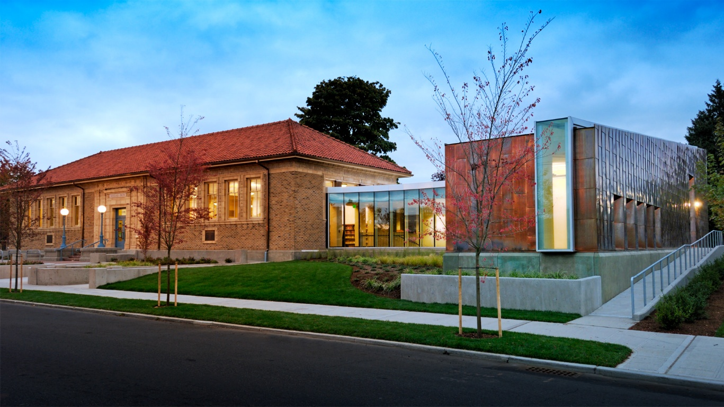
The Douglass-Truth Branch today.
Background
Originally called Yesler Memorial Library, it was renamed after Frederick Douglass and Sojourner Truth in 1975 (Bowermaster, 2006). The Douglass‑Truth Branch of The Seattle Public Library stands today as a significant cultural institution in the Pacific Northwest, because it houses one of the largest and most historically rich African American collections on the West Coast. The branch’s evolution mirrors the demographic, cultural, and political transformations of the Central District itself. Understanding the African American Collection requires understanding the community that built it, fought for it, and continues to sustain it.
The Central District of Seattle has long been a culturally diverse neighborhood. In the early twentieth century, the area was home to a large Jewish immigrant population, many of whom arrived from Eastern Europe and Russia. By the 1920s and 1930s, the Yesler Branch, as it was known then, reflected this diversity. It housed The Seattle Public Library’s entire Yiddish and Hebrew collections and offered English‑language learning support for new arrivals (Wilma, 2002). By 1932 the branch featured books in 13 different languages, serving a multilingual, multiethnic community (spl.org, n.d.).
The neighborhood shifted again in the 1920s and 1930s as Japanese American families moved into the area, restricted by racially discriminatory housing agreements that limited where people of color could live (Silva, 2009). The Yesler Branch became home to SPL’s Japanese language collection, attracting patrons from across the region. This multicultural environment was abruptly disrupted in 1942 when Japanese Americans were forcibly incarcerated during World War II (Harper, 1999, p. 12). Shamefully, the branch “lost its most loyal borrowers” during this period, and the Japanese collection was removed (Wilma, 2002).
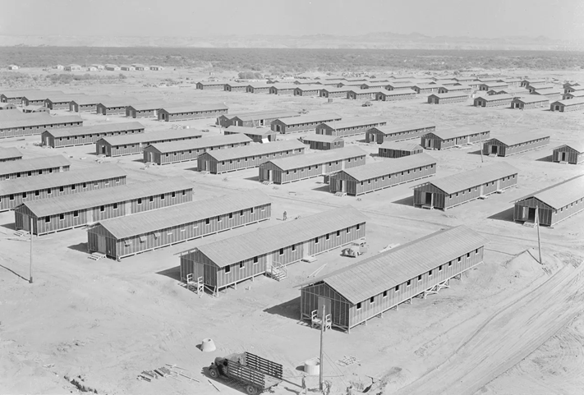
Japanese Internment Camp
At the same time, thousands of African Americans migrated to Seattle for wartime jobs in the shipyards and defense industries. Because of redlining and restrictive covenants, the Central District was the only neighborhood open to them (Taylor, 1995). This migration fundamentally reshaped the community and laid the groundwork for the African American Collection that would emerge two decades later.
Despite the demographic transformation, the library struggled to adjust. Circulation dropped, budgets were cut, and the branch fell into disrepair. Staff were unprepared to serve the new community, and some held openly biased views about African American patrons. By the early 1960s, the Yesler Branch was underfunded, understaffed, and at risk of closure (Wilma, 2002).
This decline set the stage for one of the most important chapters in the branch’s history: the arrival of librarian James A. Welsh in 1964. Welsh recognized that the library could not serve the community without understanding it. He joined the Central Area Community Council, built relationships with local leaders, and partnered with the Alpha Kappa Alpha Sorority (Wilma, 2002). This partnership would prove transformative.
In 1965, the Delta Upsilon Omega chapter of AKA donated the first set of books that would become the Negro Life and History Collection, now known as the African American Collection as an act of community preservation. The sorority’s donation “launched what was then called the Negro Life and History Collection,” and by 1969, one‑third of the branch’s adult circulation consisted of Black literature and history (spl.org, n.d.).
The collection grew rapidly through community donations, advocacy by the Black Friends of the Yesler Library, support from civil rights leaders such as Roberta Byrd Barr, Dr. Millie Russell, and Ruth Marie Brown, and a $46,000 appropriation secured through political advocacy (Wilma, 2002). The Central District community viewed the collection as not simply a library collection. To them it was a matter of identity, history, and cultural survival. By the late 1960s, the Yesler Branch had become a vital meeting place for civil rights groups. It hosted The Black Panthers, radical women, Students for a Democratic Society, and various youth groups and community forums (Wilma, 2002). This positioned the library not just as a repository of books, but as a civic and cultural anchor during a period of intense activism and social change.
Finally, by the mid‑1970s, the community sought a name that reflected its identity and history. Led by Alpha Kappa Alpha, residents organized a public vote. The result was a tie between two abolitionist icons: Frederick Douglass and Sojourner Truth. Rather than choose one, the community chose both. On December 5, 1975, the Yesler Branch officially became the Douglass‑Truth Branch (Wilma, 2002). This renaming was more than symbolic. It represented a recognition of Black history and a declaration of cultural presence in a rapidly changing city.
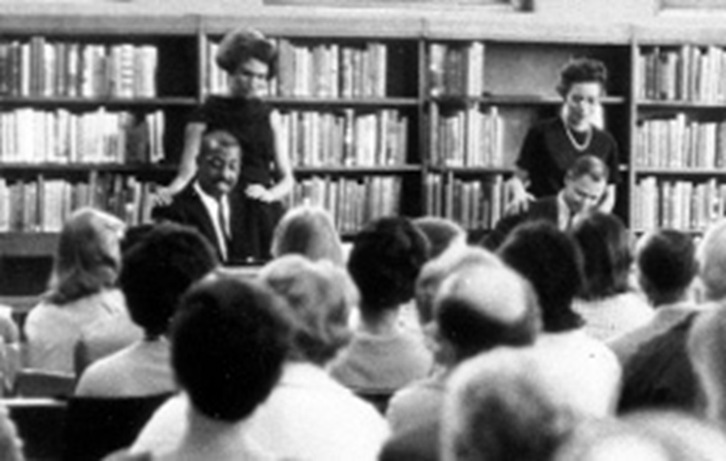
Civil Rights meeting at the Douglass-Truth Branch
One of the most iconic features of the branch is the Soul Pole, a 21‑foot sculpture representing 400 years of African American history. Created in the late 1960s by youth artists under the guidance of Raqib Mu’ied, the pole was installed in 1973 and has become a defining symbol of the Central District. It is a “beacon of Black pride,” and its 2021–2022 conservation, a collaboration between SPL, the Black Heritage Society of Washington State, and professional conservators reaffirmed its importance (Converge Staff, 2025). Its presence on the front lawn signals to every visitor that this branch is not just a library, but a site of memory, identity, and cultural continuity.
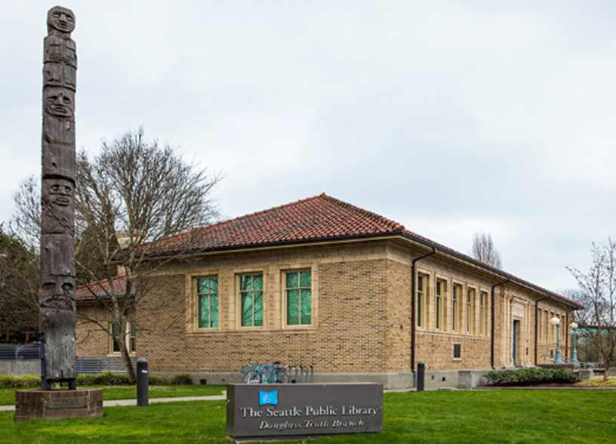
The Soul Pole as situated on the left of the Douglass-Truth Branch entrance.

The Collection
By 1969, just four years after its founding, one third of the branch’s adult circulation consisted of Black literature and history (Wilma, 2002). This rapid growth reflected both the hunger for culturally relevant materials and the community’s commitment to sustaining the collection. The Black Friends of the Yesler Library, formed in the late 1960s, played a crucial role in advocating for funding, preventing branch closure, and securing a $46,000 appropriation to expand the collection (Wilma, 2002).
The collection continued to grow through the 1970s, 1980s, and 1990s, supported by ongoing donations, community advocacy, and SPL’s recognition of the branch as a cultural anchor (SPL.org, 2025). In 2002, Douglass-Truth had the largest collection of African American literature and history on the West Coast and, with the possible exception of Texas Southern University, the largest west of the Mississippi (Wilma, 2002). Today, the collection contains over 10,000 items, including books, magazines, films, music, ephemera, and rare local materials. It remains one of the most distinctive and community driven special collections in the region (SPL.org, 2018).
The African American Collection is broad in scope, encompassing materials that document Black history, culture, literature, and lived experience across the United States, with a particular emphasis on the Pacific Northwest. According to the SPL Highlights page, the collection includes biographies, magazines (including bound volumes of Ebony and Jet dating back to the 1960s), literature (fiction, poetry, essays, drama), music and films, pamphlets, fliers, and posters that document Seattle area Black history, Northwest specific materials, including local leaders, organizations, and community issues, and contemporary titles, added regularly to maintain relevance (SPL.org, 2018) (Campbell & King, 2023).
This scope reflects a deliberate effort to balance national and regional perspectives. While the collection includes canonical works of African American literature and history, its most distinctive strength lies in its documentation of Seattle’s Black community, including materials that may not exist anywhere else. The collection’s breadth includes “books, art prints, newspaper clippings, and even dissertations from folks in the community” (Campbell & King, 2023). This diversity of formats underscores the collection’s role as both a traditional library resource and a community archive. A recent donation to the collection was from Seattle historian Jacqueline E. A. Lawson’s books on Black history including genealogies of Seattle's Black pioneer families, the Grose, Dixon-Lee, and Ball families (SPL.org, 2025).
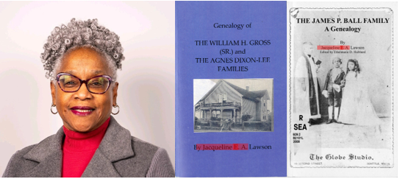
Jacquline E.A. Lawson and some of her books
Art Collection
Art and visual culture complement the collection, with significant holdings such as paintings of Frederick Douglass and Sojourner Truth by Eddie Ray Walker, three-dimensional panels by Vivian Linder, copper sculptures by Marita Dingus, a Storyquilt by Storme Webber, and the aforementioned Soul Pole (1973; conserved 2021–22). These artworks serve as visual anchors for the collection’s themes of history, identity, and resilience.
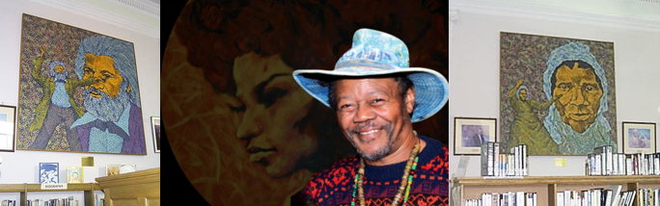
Artist Eddie Ray Walker (pictured) and his paintings of Douglass and Truth
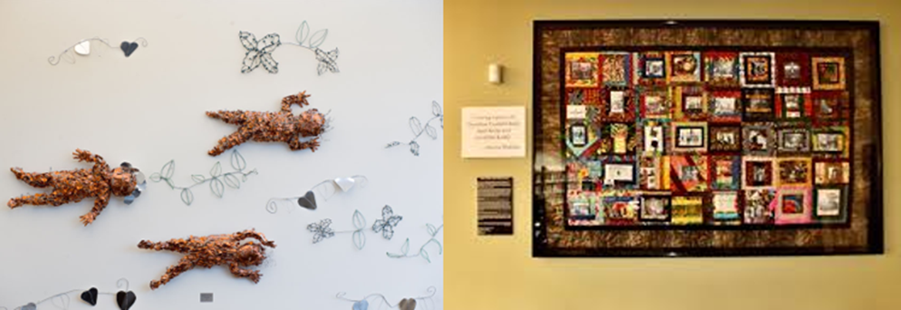
Children of the Sea Copper Sculptures by Marita Dingus and the Storyquilt by Storme Webber

Marita Dingus is a Seattle African-American artist who turns found items into works of art. In 2006, she donated “Children of the Sea”, a copper sculpture based on some dolls had found. It hangs prominently over the stacks along the back wall of the branch (Fotoeins Fotografie, 2020). Unfortunately, I could not find a rationale for the inspiration for the sculpture. Storme Webber’s Storyquilt, however, has a story behind it’s creation. Webber organized quilting circles, bringing together community members, elders, and the Northwest African American Quilters to create a collective visual narrative of Black Seattle’s history (Webber, 2021). Like the Douglass-Truth Branch, the Storyquilt is a community collaboration.
Conclusion
The African American Collection at the Douglass-Truth Branch of The Seattle Public Library stands as a monument to the enduring power of community, resilience, and cultural preservation. It may not be as flashy as the Library of Congress, but it shows what a determined community and a little leadership can achieve. From its early days as the Yesler Memorial Library, supporting waves of Jewish and Japanese immigrants, to its transformation into a hub for African American literature and activism, the library has continually adapted to meet the needs of a changing population. And that is pretty fantastic, in my opinion. Communities are not static. They are ever changing with the times.
Today, the collection is more than a repository of books and artifacts; it is a living archive that documents the stories, struggles, and achievements of Black Seattleites and the broader African American experience. Its holdings, ranging from rare genealogies and local histories to vibrant artworks, underscore the importance of libraries as spaces of memory, identity, and empowerment.
As the Douglass-Truth Branch continues to evolve, its collection remains a beacon for future generations, reminding us that the preservation of history is not a passive act but an ongoing collaboration between libraries and the communities they serve. In honoring the past, the African American Collection inspires hope, pride, and a sense of belonging for all who walk through its doors.

References
Bowermaster, D. (2006, October 15). Check out the historic new Douglass-Truth branch library. The Seattle Times.
Campbell, K., & King, A. (2023, February 27). Celebrate Black literature and history all year long at Seattle Public Library's Douglass-Truth Branch. Retrieved from KUOW.org: https://www.kuow.org/stories/celebrate-black-literature-history-all-year-seattle-public-library-douglass-truth-branch
Converge Staff. (2025, December 15). 'The Legacy Of The Soul Pole’: A Beacon of Black Pride, Preserved. Retrieved from Converge Media: https://www.whereweconverge.com/post/the-legacy-of-the-soul-pole-a-beacon-of-black-pride-preserved
Fotoeins Fotografie. (2020, March 7). Seattle: living black history in the C.D. Retrieved from Fotoeins Fotografie: https://fotoeins.com/2020/07/27/my-seattle-black-history/
Gentry, L. (2025, November 21). The Seattle Public Library Celebrates 50 Years of ‘Douglass-Truth’. Retrieved from The Seattle Public Library: https://www.spl.org/about-us/news-releases/the-seattle-public-library-celebrates-50-years-of-douglass-truth
Harper, K. (1999, September 15). Truth At The Crossroads. Retrieved from The Seattle Public Library: https://cdm16118.contentdm.oclc.org/digital/collection/p16118coll37/id/3188/rec/1
Silva, C. (2009, February 12). Segregated Seattle. Retrieved from The Seattle Civil Rights & Labor History Project: https://eastsideforall.org/wp-content/uploads/2020/01/Racial-Restrictive-Covenants_-Enforcing-Neighborhood-Segregation-in-Seattle-Seattle-Civil-Rights-and-Labor-History-Project.pdf
SPL.org. (2018, February 15). Douglass-Truth Branch Highlights. Retrieved from The Seattle Public Library: https://www.spl.org/books-and-media/unique-collections/african-american-collection
SPL.org. (2025). African American Collection. Retrieved from The Seattle Public Library: https://www.spl.org/books-and-media/unique-collections/african-american-collection
spl.org. (n.d.). Douglass-Truth Branch Highlights. Retrieved from The Seattle Public Library: https://www.spl.org/hours-and-locations/douglass-truth-branch/douglass-truth-branch-highlights
Taylor, Q. (1995, Summer). Swing the Door Wide: World War II Wrought a Profound Transformation in Seattle’s. Columbia Magazine, 9(2), pp. 26-32. Retrieved from https://www.washingtonhistory.org/wp-content/uploads/2020/04/swing-door-wide.pdf
Webber, S. (2021, March 19). How Tallulah, Louisiana Barbeque Inspired a Quilt. Retrieved from Historic Seattle: https://historicseattle.org/sfs0321/
Wilma, D. (2002, December 26). Douglass-Truth Branch, The Seattle Public Library. Retrieved from History Link: https://www.historylink.org/File/4056

